1. Two ships leave port P at the same time. One ship sails 50 Km on a bearing of 028° to position A. The other ship sails on a bearing of 098° to position B.

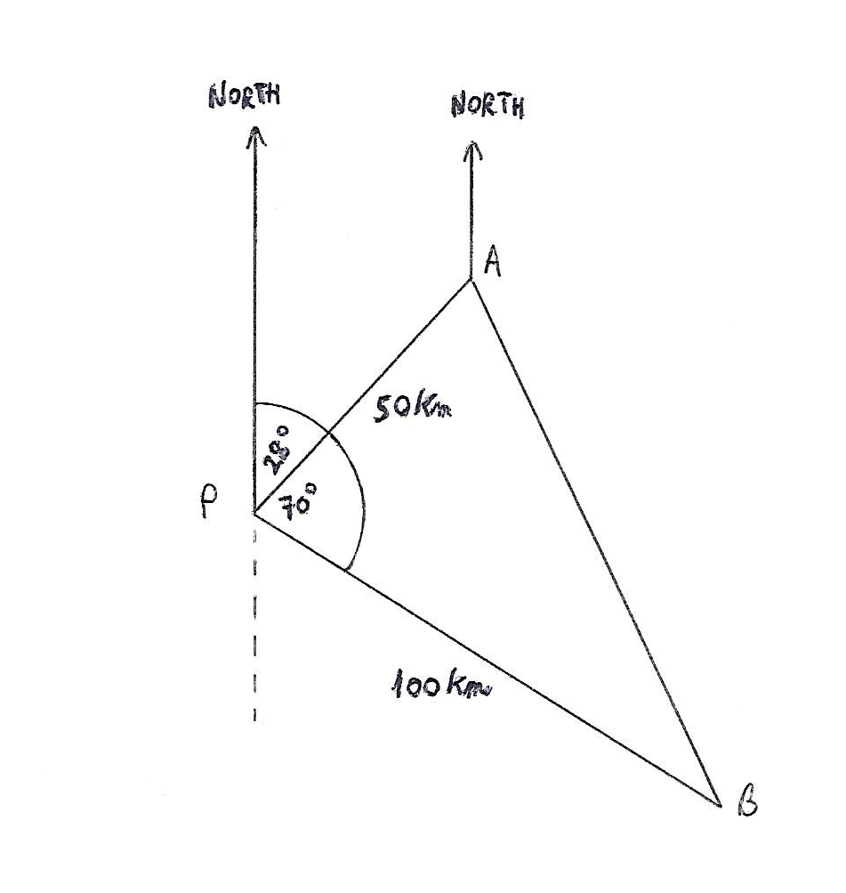

1. Calculate:
2. the distance AB
3. PÂB
4. The bearing of B from A.
5. Both ships took the same time, t hours, to reach their positions. The speed of the *faster* ship was 20 Km/h. Write down:
6. The value of t

(ii) The speed of the slower ship

(5 Marks)

2. This is a record of sales of ice cream on days with the average temperature as shown for each day.

|  |  |  |  |  |  |  |  |  |  |  |  |  |
| --- | --- | --- | --- | --- | --- | --- | --- | --- | --- | --- | --- | --- |
| Temperature °C | 14.2 | 16.4 | 11.9 | 15.2 | 18.5 | 22.1 | 19.4 | 25.1 | 23.4 | 18.1 | 22.6 | 17.2 |
| Ice cream sales $ | 215 | 325 | 185 | 332 | 406 | 552 | 412 | 614 | 544 | 421 | 445 | 408 |

1. Draw a scatter diagram for this data with the volume of sales shown on the vertical axis. (2 marks)
2. Comment on the strength of correlation. (1 mark)
3. Draw a line of best fit for this data. (1 mark)
4. Estimate the volume of ice cream sold on a day temperature averaging 20°. (1 mark)
5. Could you predict the sales volume if the temperature were 30°? Give reasons for your answer. (2 marks)

3. An employee’s salary has increased to £39,940.81p per year in 3 years at 4.5% per year.

(a) What did he earn 3 years ago? (1 mark)

(b) What is his gross monthly salary at the present rate? (1 mark)

(c) He is deducted 19.5% each time he is paid. What is his net pay per month? (1 mark)

4. This graph could be used to show increase in bacteria numbers over a period of time, using the formula

y = 1.2x – 1 to represent it. The scales are:

Y axis, 1 unit = 100 bacteria

X axis, 1 unit = 1 hour.

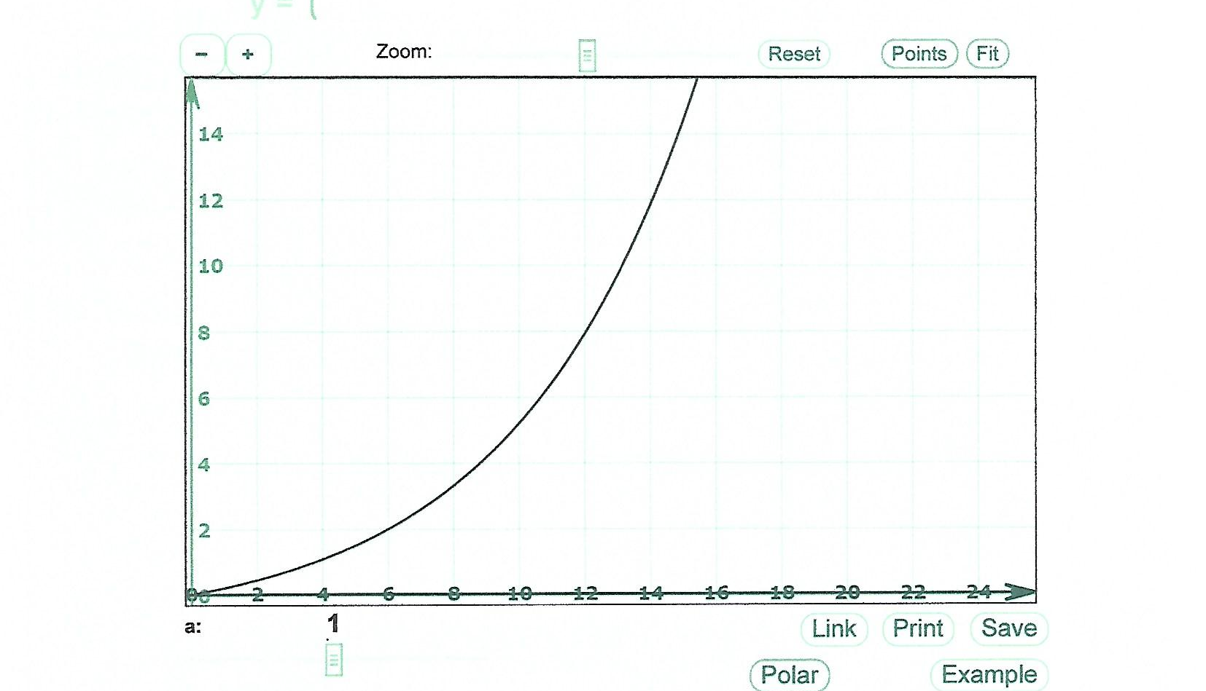

1. How many bacteria are there after 6 hours? (1 mark)
2. How long does it take for the number of bacteria to exceed 80 cells? (1 mark)
3. How many will there be after 14 hours? (1 mark)
4. Confirm this using the formula. (1 mark)
5. When would you expect the population to exceed 1 million if growth continued to adhere to this formula? (1 mark)

You will need to know to use logarithms in this case: to find the logarithm to base 10 of y = 1.2x – 1, find the logarithm of each term in the formula and make x the subject on the left of the equation.